**Question 3**

**The Existing Book Database Available**

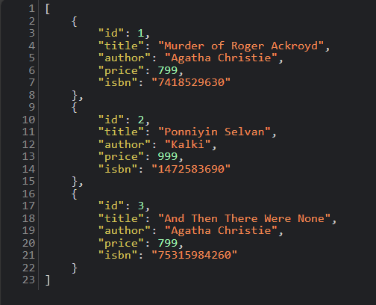

**Fetch a Book By ID**



**Search a Book By Title**



**Search Book By Author**



**Search a book by title and Author**

